Patient History Form

North Houston Rheumatology Associates
MARITAL STATUS:
o Married
Spouse/Significant Other: o Alive/Age __ o Deceased/Age Major Illnesses _

EDUCATION (circle highest level attended):
College
Grade School 7 8 9 10 11 12

Occupation __________________________________ Number of hours worked/average per week _______
Graduate School:
Name of person making referral:
The name of the physician providing your primary medical care:
Do you have an orthopedic surgeon? o Yes o No If yes, Name:
Describe briefly your present symptoms: _____________________
_______________________________________________________
_______________________________________________________
_______________________________________________________
Referred here by: (check one)
o Self
o Family
Date symptoms began (approximate): ________________________
Diagnosis:_____________________________________________
Previous treatment for this problem (include physical therapy,
surgery and injections; medications to be listed later)
_______________________________________________________
_______________________________________________________
_______________________________________________________

Please list the names of other practitioners you have seen for this
problem:
RHEUMATOLOGIC (ARTHRITIS) HISTORY
1 2 3 4
o Friend
o Doctor
o Other Health Professional
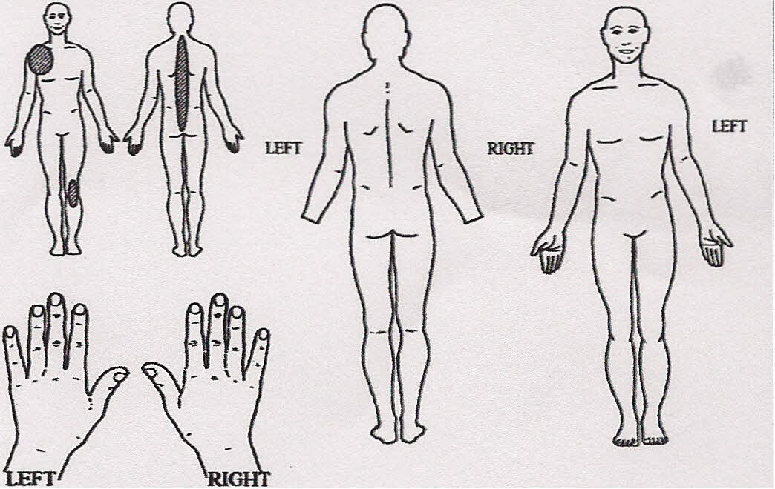
Example:
Please shade all the locations of your pain over the
past week on the body figures and hands.

Adapted from CUNHAQ, Wolle F and PinaJS T. CUrrent
Comment- Uslening to the patient - A
practical guide fD self report ~onnaires in dinical care. Arthritis Rheum. 1999;42 (9):1797-
808. Used by pemission.
At any time have YOU or a blood relative had any of the following? (check if "yes")
Yourself |  | Relative | Yourself |  | Relative
 |  | Name/Relationship |  |  | Name/Relationship
 | Arthritis (unknown type) |  |  | Lupus or "SLE"
 | Osteoarthritis |  |  | Rheumatoid Arthritis
 | Gout |  |  | Ankylosing Spondylitis
 | Childhood arthritis |  |  | Osteoporosis
Other arthritis conditions:

Patient's Name ___________________________________Date Physician Initials.__________
Patient History Form © 1999 American College of Rheumatology
o Never Married
o Divorced
o Separated
o Widowed
Name: ___________________________________________ Date of Birth: _________________
__________________________ _________________ __________
SYSTEMS REVIEW
As you review the following list, please check any of those problems, which have significantly affected you.

Date of last mammogram ______/ / Date of last eye exam ______/ / Date of last chest x-ray _____/_____/

Date of last Tuberculosis Test _____/_____/______Date of last bone densitometry ______/ /

Constitutional
o Recent weight gain
Amount
o Recent weight loss
Amount
- Fatigue
- Weakness
- Fever
Eyes
- Pain
- Redness
- Loss of vision
- Double or blurred vision
- Dryness
- Feels like something in eye
- Itching eyes
Ears-Nose-Mouth- Throat
- Ringing in ears
- Loss of hearing
- Nosebleeds
- Loss of smell
- Dryness in nose
- Runny nose
- Sore tongue
- Bleeding gums
- Sores in mouth
- Loss of taste
- Dryness of mouth
- Frequent sore throats
- Hoarseness
- Difficulty in swallowing
Cardiovascular
- Pain in chest
- Irregular heart beat
- Sudden changes in heart beat
- High blood pressure
- Heart murmurs
Respiratory
- Shortness of breath
- Difficulty in breathing at night
- Swollen legs or feet
- Cough
- Coughing of blood
- Wheezing (asthma)

Gastrointestinal
- Nausea
- Vomiting of blood or coffee ground
Mater ial
- Stomach pain relieved by food or milk
- Jaundice
- Increasing constipation
- Persistent diarrhea
- Blood in stools
- Black stools
- Heartburn
Genitourinary
- Difficult urination
- Pain or burning on urination
- Blood in urine
- Cloudy, "smoky" urine
- Pus in urine
- Discharge from penis/vagina
- Getting up at night to pass urine
- Vaginal dryness
- Rash/ulcers
- Sexual difficulties
- Prostate trouble
For Women Only:
Age when periods began: _
Periods regular? 0 Yes 0 No
How many days apart? _
Date of last period? _____/ ____/_____
Date of last pap? _____/ ____/_____
Bleeding after menopause? 0 Yes 0 No
Number of pregnancies? _
Number of miscarriages? _
Musculoskeletal
o Morning stiffness
Lasting how long?
______ Minutes_______Hours
- Joint pain
- Muscle weakness
- Muscle tenderness
- Joint swelling
List joints affected in the last 6 mos.
_____________________________
_____________________________
_____________________________
_____________________________

Integumentary (skin and/or breast)
- Easy bruising
- Redness
- Rash
- Hives
- Sun sensitive (sun allergy)
- Tightness
- Nodules/bumps
- Hair loss
- Color changes of hands or feet in the
cold
Neurological System
- Headaches
- Dizziness
- Fainting
- Muscle spasm
- Loss of consciousness
- Sensitivity or pain of hands and/or feet
- Memory loss
- Night sweats
Psychiatric
- Excessive worries
- Anxiety
- Easily losing temper
- Depression
- Agitation
- Difficulty falling asleep
- Difficulty staying asleep
Endocrine
o Excessive thirst
Hematologic/Lymphatic
- Swollen glands
- Tender glands
- Anemia
- Bleeding tendency
- Transfusion / when? _
Allergic/Immunologic
- Frequent sneezing
- Increased susceptibility to infection

Patient's Name Date Physician Initials
Patient History Form © 1999 American College of Rheumatology

SOCIAL HISTORY
Do you drink caffeinated beverages?
Cups/ glasses per day?
Do you smoke? o Yes o No o Past - How long ago?
Do you drink alcohol? o Yes o No Number per week
Has anyone ever told you to cut down on your drinking?
o Yes o No
Do you use drugs for reasons that are not medical? o Yes o No
If yes, please list: ______________________________________

_______________________________________________________
Do you exercise regularly? o Yes o No
Type
Amount per week
How many hours of sleep do you get at night?
Do you get enough sleep at night? o Yes o No

PAST MEDICAL HISTORY
Do you now or have you ever had: (check if "yes')
o Cancer 0 Heart problems 0 Asthma
o Goiter 0 Leukemia 0 Stroke

o Cataracts | o Diabetes | o Epilepsy
o Nervous breakdown | o Stomach ulcers | o Rheumatic fever
o Bad headaches | o Jaundice | o Colitis
o Kidney disease | o Pneumonia | o Psoriasis
o Anemia | o HIVIAIDS | o High Blood Pressure
o Emphysema | o Glaucoma | o Tuberculosis
Other significant illness (please list) _
Natural or Alternative Therapies (chiropractic, magnets, massage,
over-the-counter preparations, etc.)

Do you wake up feeling rested?
Previous Operations

o Yes o No

Type | Year | Reason
1.
2.
3.
4.
5.
6.
7.
Any previous fractures? o No o Yes Describe: _
Any other serious injuries? o No o Yes Describe: _
FAMILY HISTORY:

 |  | IF LIVING |  | IF DECEASED
 | Age | Health | Age at Death | Cause
Father
Mother
Number of siblings: Number living: Number deceased : _
Number of children Number living Number deceased List ages of each _
Health of children: _____________________________________________________________________________________________________________________

Do you know of any blood relative who has or had: (check and give relationship)
o Cancer___________________ o Heart disease _______________ o Rheumatic fever _

o Tuberculosis ___________ _

o Leukemia _
o Stroke _
o Colitis _

o High blood pressure _
o Bleeding tendency _
o Alcoholism _

o Epilepsy___________ _
o Asthma _
o Psoriasis _

o Diabetes _
o Goiter _

__________________________ _________________ _________

Patient's Name___________ _ Date Physician Initial
Patient History Form © 1999 American College of Rheumatology

MEDICATIONS
Drug allergies: o No
o Yes
To What? __________________________________________________________________________________________
______________________________________________________________________________________________
Type of reaction: _
PRESENT MEDICATIONS (List any medications you are taking Include such items as aspirin vitamins laxatives calcium and other supplements etc)
Name of Drug | Dose (include | How long have | Please check: Helped?
 | strength & number of | you taken this | A Lot | Some | Not At All
 | pills per day) | medication
1. |  |  | 0 | 0 | 0
2. |  |  | 0 | 0 | 0
3. |  |  | 0 | 0 | 0
4. |  |  | 0 | 0 | 0
5. |  |  | 0 | 0 | 0
6. |  |  | 0 | 0 | 0
7. |  |  | 0 | 0 | 0
8. |  |  | 0 | 0 | 0
9. |  |  | 0 | 0 | 0
10. |  |  | 0 | 0 | 0
PAST MEDICATIONS Please review this list of "arthritis" medications. As accurately as possible, try to remember which medications you have taken.
Drug names l Dosage
Non-Steroidal Anti-inflammatory Drugs (NSAlDs) |  |  |  | Circle any you have taken in the past
Ansaid (flurbiprofen) | Arthrotec (diclofenac + misoprostil) Aspirin |  |  |  |  | AspiriAs |  |  |  |  |  | Celebrex |  |  | Clinoril (sulindac)
Daypro (oxaprozin) | Disalcid (salsalate) |  |  | Dolobid |  |  | Feldene (piroxicam) |  |  |  | Indocin (indomethacin) |  |  |  | Lodine (etodolac)
Meclomen |  | Motrin/IbIbuprofen |  |  | Nalfon (fenoprofen) |  |  |  |  | Naprosyn |  |  | Oruvail (ketoprofen)
Tolectin (tolmetin) | Trilisate (choline magnesium trisalicylate) Vioxx |  |  |  |  |  |  |  |  | Voltaren (diclofenac)
Pain Relievers
Acetaminoohen (Tvlenol)
Codeine (Vicodin, Tylenol 3) | 3)
Proooxvohene lDarvonlDarvocet)
Other:
Disease Modifvina Antirheumatic Druas (DMARDS)
Hvdroxvchloroauine (Plauuenil)
Penicillamine (Cunrirnine or Deoen\
Methotrexate (Rheumatrex)
Azathioprine (lmuran)
Sulfasalazine (Azulfidine)
Cvcloohosohamide (Cvtoxan\
Etanercept (Enbrel)
Infliximab (Remicade)
Other:
Patient's Name Date Physician Initials _
Patient History Form © 1999 American College of Rheumatology
__________________________ _________________ _________

